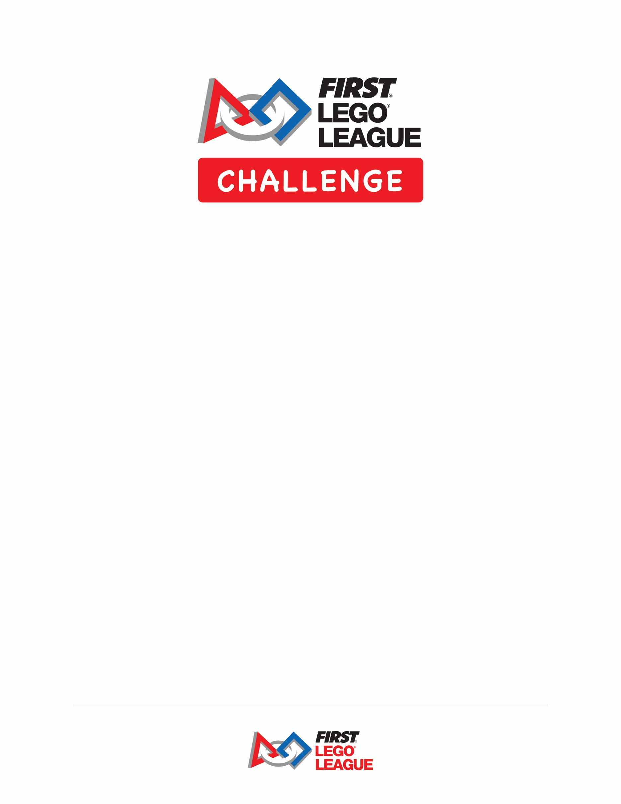

BIOGLOW™ Opening Ceremony Script Template
Opening Ceremony
Speaker | Dialogue | Blocking Notes
 |  | Open the ceremony with a Parade of Teams. (Optional)
 |  | A/V: Play some fun music as the teams parade in – Emcee can introduce each team, or teams can introduce themselves).
Emcee | Welcome to the [Insert Tournament Name]! Today, we are here to celebrate the achievements of the FIRST® LEGO® League Challenge teams that are here!
Emcee | My name is [insert Name] and I will be your Master of Ceremonies.  To open our event, we would like to pay our respects with a Welcome/Acknowledgement of Country. | Invite suitable guest to make welcome or acknowledgement of country – could be a team member, coach, parent, local elder, etc.
Emcee | Let’s get this BIOGLOW™ event started!
Emcee | In this year’s BIOGLOW Challenge, part of the FIRST® CANOPY season, teams around the world explored the vibrancy of the world’s ecosystems.  Here’s a glimpse at the BIOGLOW Challenge.
Video Package |  | A/V: Play BIOGLOW teaser video

Emcee | This is an official FIRST LEGO League BIOGLOW tournament. FIRST and The LEGO Group partnered to create our program in 1998. FIRST LEGO League started that year with 200 teams. This season, hundreds of thousands of kids in over 100 countries are participating around the world! Teams prepared for this tournament by working together, and we can’t wait to see what they’ve accomplished.
Emcee | For the BIOGLOW Innovation Project, teams were challenged to identify and research a problem that puts biodiversity at risk and design an innovative solution that can help.  Teams also designed and created a robot to complete the missions in the Robot Game. In the Robot Game, teams race against the clock to complete as many missions as they can in a two-and-a-half minute match.
Emcee | The Robot Game and Innovation Project are what we do. Our FIRST Core Values support how we do what we do. When things get tough out there today, you never want to forget about Gracious Professionalism®. It means competing like crazy against the clock, but treating each other with respect. Keep that in mind if you get a little tired or something goes wrong. We all have more fun – teams, coaches, parents, and volunteers – when we treat each other with Gracious Professionalism.
Emcee | Let’s meet our judges! Would all the judges please stand? Judges evaluate teams in three areas – Innovation Project, Robot Design, and Core Values. [Insert Name of the Judge Advisor] is the Judge Advisor for this tournament. Please give them and all our judges a huge round of applause! | Judges stand

Emcee | Judges are great, but what about the folks dressed in the black and white stripes? Would our referees please stand!? Referees serve as the Robot Game officials. [Insert Name of Head Referee] is our tournament’s Head Referee. Please give them and our entire referee team a round of applause! | Referees stand
Emcee | This tournament is only possible due to the hard work and dedication of our volunteers, who have come out in force to support this tournament. Volunteers please stand, or if you are already standing, please wave! Thank you for your service. Let’s hear it for our volunteers!
Emcee | We also want to give a nod to our FIRST LEGO League Global Sponsors: LEGO Education and The LEGO Foundation, and our FIRST LEGO League Challenge Division Sponsors, Rockwell Automation and 3M. We also thank our Australian National Sponsors, FIRST Australia and Macquarie University.  We also cannot thank our wonderful local sponsors enough, whose support has made this tournament possible. They are: [list tournament sponsors].
Emcee | Emcee shares any emergency procedures or housekeeping information with the audience and informs the audience where to get information. Some information to keep in mind that you might want to add here:  - Maintain respect for the building and others  - Keep areas clear and free of clutter  - Schedule information  - Clarification about where spectators can visit and where they can’t (like team, coach, and volunteer only areas)  - Locations of various Outreach Activities (including FIRST® LEGO® League Explore, if applicable)  - Where the Information table is located  - How to find the food and vending areas  - Promote sportsmanship and have fun!
Emcee | Good luck teams! Let the games begin!
 |  | A/V - Play energising music
Total time for Opening Ceremony –
- Script time: 10 – 15 minutes, excluding the Parade of Teams.
- Parade of Teams: Add 30 seconds per team (optional addition)
- Guest Speaker: Add 5 minutes per speaker – provide the speaker with a time limit and/or prepare some remarks to help control the time

You can always add a guest speaker (related-Challenge expert or other VIP, i.e. major sponsor representative or spokesperson for the host site). The speaker can be placed following the National Anthem or later in the ceremonies. Try not to bog down your ceremonies with too many talking heads.

You can play an audio recording or video of the National Anthem, or you can invite a singer to sing it, or a musical group to perform it. (Per local protocol)

Bottom line? The ceremony is yours to create! This template was created to make the process easier for you.

