

Insert event name and date info here.
Team Information Packet
Table of Contents
FIRST® LEGO® League Challenge Qualifier 2
Tournament Date, Time, Location and Contact 2
Customize Your Schedule 2
Directions 2
Parking 2
Food 2
Dress 2
Team Size 3
Team Check-in 3
Pit Area 3
Coaches’ Meeting 4
Judging 4
Opening Ceremony 5
Spectators 6
Robot Game 6
Awards 6
Championship Advancement 7
What is Gracious Professionalism®? 7
Tournament Cancellation Policy 7
Competition Day Checklist 7

(Tournament Title)

FIRST® LEGO® League Challenge Qualifier

Tournament Date, Time, Location and Contact
Date: (Month & Day, Year)
Time: (Insert times)
Location: (Venue Name, Address)
Tournament Contact: (Name of Team Contact for this Event & Email or Phone Number)

Customize Your Schedule
Time | Activity
7:30 AM | Team Check-in & Pits Open
7:45 AM | Coach Meeting
8:30 AM | Judging Begins (All Judging is CLOSED to the public)
9:00 AM | Practice Round Begins (Open to the Public)
11:45 AM | Opening Ceremony (Open to the Public)
12:30 PM | Official Robot Rounds Begin (Open to the Public)
2:10 PM | Robot Game Ends
2:30 PM | Closing Ceremony (Open to the Public)

Directions
(You can delete this or you can add driving directions or a link to the directions if you are referencing an on-line mapping tool. Considering the abundance of personal GPS tools, many events do not find it necessary to include driving directions).

Parking
(Include information about parking – perhaps teams will follow signage to know where to park or enter the venue parking lot – you can include the required team and spectator facility entrance points in this area, too).

Food
(Include how meals will be handled here. Consider the following when adding information to this section:
- Will concessions be provided on-site?
- How much will food cost? You could add a menu and pricing.
- Perhaps you are working with a vendor to provide lunches to teams – will they be required to pre-order and pre-pay? Include that information here.
- Will you permit teams to bring food into the facility? Are coolers permitted? Some venues do not allow this.
- Where will teams eat? Include the areas where food is permitted and where food is not permitted.
- This is an all-day event, so include whether items will be available to teams early in the morning, too – coaches, especially, will want to know if they will be able to purchase coffee!)

Dress
Dress for all teams is casual. We encourage your team to adopt a fun and unique team identity, which allows others to understand something about your team, your engineering experience, or your Innovation Project. Remember to HAVE FUN!

Team Size
A competitive team consists of a minimum of two (2) and a maximum of ten (10) children. Team members must be between the minimum and maximum age or grade allowed in their region.

Team Check-in
Team check-in will run from 7:30 AM – 8:15 AM.
Coaches must submit the following for their teams to the team check-in volunteers:
- Team Roster (for United States and Canadian regions): Download your team roster from the Team Registration System, print a copy, and bring it to team check-in. A FIRST Consent form is required for every team member, coach, and mentor who will be with the team during the competition day.
Your team will receive the following at Team Registration:
- Team Badges or Lanyards: One badge will be provided for each team member and two coaches. Your team will only receive two coach badges, even if your team works with more than two coaches and mentors. Your team will need to decide what two adults will be spending the day with the students. NOTE: At least one adult coach is required to supervise the team at all times during the tournament.
- Schedule of Events and/or a Program Book: Your team will be provided information about the tournament day, including a competition schedule.
- Additional Information: (Include additional information regarding ceremony procedures, practice table reservation procedures, emergency procedures, etc. – you can let the teams know here what additional information that they can expect to receive at team registration).

Pit Area
The Pit is where your team will spend most of the time. This is where you will work on your robot and programming. This is also the area where you can enjoy downtime with your team, get to know other teams, see their robots, and find out about their Innovations Projects. Your team will have access to:
- One standard-sized table
- At least two (2) chairs
- Electricity – Bring an extension cord and a power strip, as your access point will consist of a single outlet/plug. A power strip will allow you to charge your robot and your laptop at the same time.
We recommend that you bring the following for your team to have in the Pit Area:
- A bin or large bags (like trash bags) to store personal belongings, like coats, under your table
- Your robot and all your robot supplies (attachments and additional building pieces)
- Your laptop computer and power cord
- An extension cord and power strip
- A box or small bin to carry your robot and attachments to and from the competition area. You must unload all your equipment onto the table at official matches.
- Games (there will be long periods of downtime – bring some small games that the team can play when things are slow)
Some Pit Area Rules for you to keep in mind:
- Coaches should refrain from handling the robot, attachments, or the computer. NOTE: If your team encounters technical difficulty, let someone at the tournament know so that the officials at the event understand why a coach might need to handle a robot or work on the computer.
- Remember to be gracious professionals when using a Practice Table:
  - Include any rules regarding the Practice Table sign-up process.
  - Be mindful of your time and other teams’ needs. Please be courteous and allow a team facing a crisis to use your practice time).
  - Reset the Practice Table for the next team.
  - Make sure you check that you do not take a mission model from the Practice Table
  - Offer help to teams that may need it!

Coaches’ Meeting
The Coaches’ Meeting will be held in the Competition Area at 7:45 AM. At least one team coach should attend this meeting. Make sure that another coach or mentor is assisting the team to set up their pit area during this time. At this meeting, your team’s coach will have the opportunity to:
- Meet the Tournament Director
- Meet the Head Referee
- Understand the flow pattern through the competition area
- Ask judging-related questions
- Ask Robot Game questions
- Ask any other tournament-related questions

Judging
Team judging begins at 8:30 AM. Each team will be judged within a single judging session. Your team will spend ten (30) minutes with your assigned judging pod.
Only team members and two (2) coaches will be allowed into the judging rooms. One team coach will be permitted to videotape the judging session; however, that adult should remain in designated areas. Nobody from the team should stand behind the judges. Coaches should be silent observers of the judging process and refrain from influencing the session in any way. If you choose to use a PowerPoint presentation, check what AV equipment will be available for the teams in the judging pod. The judging schedule is tight. Please be on time for your judging session.

All cell phones (team members & coaches) must be turned off during the judging sessions.

Please make sure to review the rubrics with your team prior to coming to the event. The following outlines what you can expect in each of the judging session:

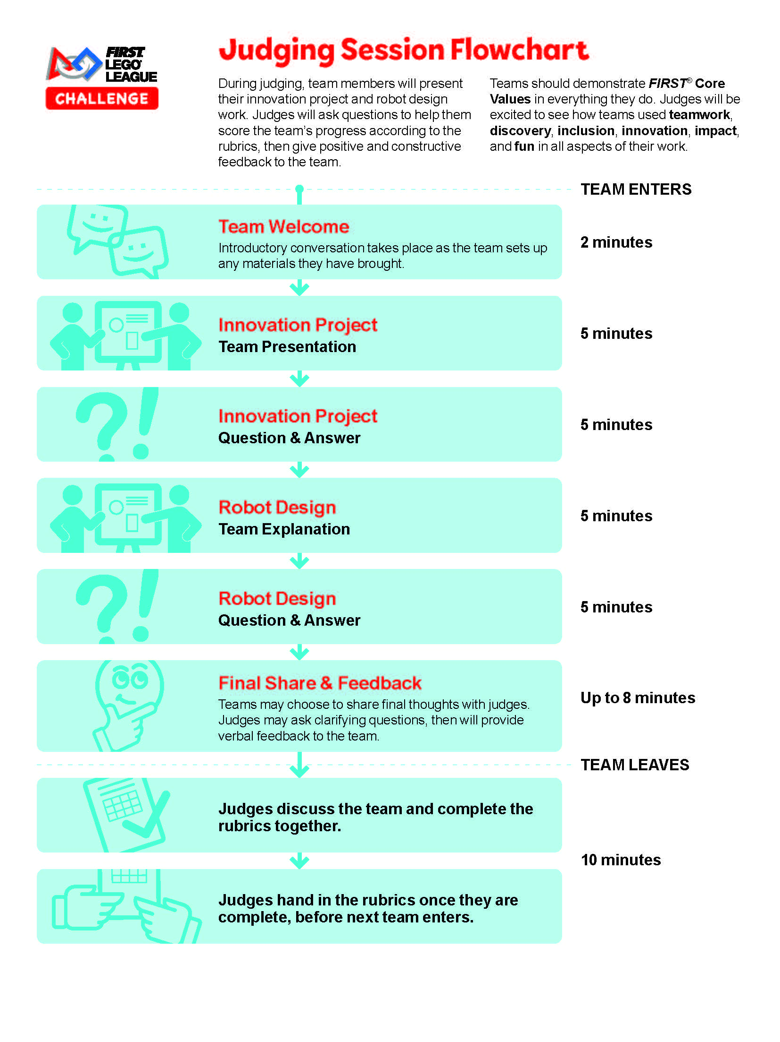

Opening Ceremony
At 11:45 AM just prior to the start of the Robot Performance rounds, join us for the Opening Ceremony! This is a fun celebration to open the spectator portion of the event and will occur after your judging sessions are complete. The ceremony will begin with a Parade of Teams – bring your team banners or signs (if you have them) and your team spirit! After this ceremony, you will be ready to tackle the Robot Game!

Spectators
The Robot Game is free and open to the public, starting at 12:30 PM. The judging portion of the event, which will happen all morning, is closed to the public. Thank you for respecting this policy. Please remember to respect the team-only areas – the competition floor area (the area where teams queue and compete) and the judging area.

Robot Game
Your team is responsible for knowing and understanding the FIRST LEGO League Challenge Robot Game. All the game documents can be found on the FIRST LEGO League website.

You are required to know the following for the robot competition: Field Setup, Rules, Missions, and Robot Game Updates.

Housekeeping: (In this space, explain to the teams any housekeeping support you plan to provide them.)

Coaches: Two coaches will be permitted to join the team on the competition floor, but you must stay behind the line with the team and refrain from actively directing the team during the game. Please do not touch or handle the robot or attachments during this time. Consider yourselves spectators with the best spot in the house to watch the game.

Your team will participate four (4) times at the Tournament Tables – the Robot Game will begin with a Practice Round. The purpose of the Practice Round is to give your team the opportunity to experience the queuing process, competition timing, and of course, to get rid of some of those nerves. This Practice Round is just that – a practice – and it does not count, even if this is the best score your team has at this tournament. Your Robot Performance score is the highest score your team achieves out of the three official rounds.

NOTE: Remote controls are not allowed anywhere at this tournament (This includes Smartphone applications that enable you to control your robot remotely). Bluetooth may not be used. Your team could be disqualified if you are found remotely controlling your robot anywhere during the competition or if your Bluetooth is enabled in the competition area!
Make sure you are ready to compete at least ten (10) minutes prior to your scheduled robot round. Remember to respect the referees and the other teams – and HAVE FUN!

Awards
Descriptions of FIRST LEGO League Challenge awards can be found here. The following awards will be presented at this tournament:

- Champion’s Award
- Core Values Award
- Innovation Project Award
- Robot Design Award
- Robot Performance Award
- Coach/Mentor Award
- Engineering Excellence Award
- Breakthrough Award
- Rising All-Star Award
- Motivate Award

Championship Advancement
(Include number teams advancing) teams from this tournament will be invited to advance to the (Championship name) FIRST LEGO League Championship held on (Championship tournament date and location), based on Champion’s rank.

What is Gracious Professionalism®?
Gracious Professionalism® is part of the ethos of FIRST®. The idea and phrase are found throughout FIRST, but no one has been a stronger champion than FIRST Executive Advisory Board Co-Chair & Distinguished Advisor, Dr. Woodie Flowers. “Gracious Professionalism is a way of doing things that encourages high-quality work, emphasizes the value of others, and respects individuals and the community. With Gracious Professionalism, fierce competition and mutual gain are not separate notions. Gracious Professionals learn and compete like crazy but treat one another with respect and kindness in the process.”

We expect all team members, volunteers, coaches, and families to behave as Gracious Professionals.

Tournament Cancellation Policy
(Include your tournament’s policy for cancelling this event – the following is a sample: “The (name) qualifying tournament will be canceled or delayed due to causes and conditions beyond the tournament organizers’ control, including, but not limited to inclement weather, acts of nature, government restrictions, and/or any other cause beyond the tournament organizers’ control. Please refer to local news and radio for current county advisories. If the event must be canceled, it will not be rescheduled, and advancement to the (Championship Name) FIRST LEGO League Championship will be determined by lottery of teams registered for this event.”)

Competition Day Checklist
Team Roster for teams competing in United States and Canadian regions
Robot, attachments, extra parts
Fresh batteries/spare batteries/rechargeable battery charger
Computer and battery (if available) and power cord
USB download cable (Bluetooth use is NOT permitted at the tournament)
Extension cord and power strip
Box to carry robot to competition field
Provisions for lunch (check with tournament director for options)
Bin to hold personal and team items (coats, games, etc.) to fit under pit table
Project judging materials, props, and displays
Graphics demonstrating programming strategy for robot design judging
Team games or activities for downtimes (optional)
Team banner or poster to carry for ceremonies or for pit space (optional)
Team giveaways (optional)

